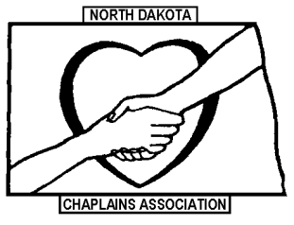

NDCA 2023 membership dues are $50/year for full-time chaplains and $40/year for part-time and retired chaplains, or student interns.

Membership dues are payable to NDCA or North Dakota Chaplains Association.

Whether you are a current member or would like to become one, please submit the following application information along with your dues.

Name______________________________________________________________

Institution__________________________________________________________

Address____________________________________________________________

Work phone_______________________Home/cell phone___________________

Email address_______________________________________________________

Full-time ($50)_______ Part-time, retired, or student ($40)_______

Return to:
Ron Hildahl
Anne Carlsen Center
701 3rd St. NW
Jamestown, ND 58401

Thank you for your membership!
www.ndchaplains.com

